**Manuscript Number**: 308025

**Title**: High-power Self-mode-locked Pr:YLF Visible Lasers

**Authors**: Saiyu Luo et al.

Answers (**in blue**) to the reviewers’ comments:

**Reviewer #1**

1. Information on the pump source and beam shaping is missing.
   1. What is the M2 of the diode lasers? Blue laser diodes are knows for asymmetrical beam qualities.

**Response**:

The diode laser pump sources used in our experiments were commercially made and have already been collimated, the divergence of output laser beam was said to be less than 0.3 mrad (full angle), according to the instruction of the product. The M2 factors in the x and y direction after focusing by the 50 mm focal lens were measured to be 25.7 and 12.3, respectively. The intensity profile of the laser diode recorded by using CCD camera has been demonstrated in our previous work [10].

[10] B. Xu, Y. J. Cheng, B. Qu, S. Y Luo, H. Y. Xu, Z. P. Cai, P. Camy, J. L. Doualan, R. Moncorgé, “InGaN-LD-pumped Pr3+:LiYF4 continuous-wave deep red lasers at 697.6 and 695.8 nm,” Optics & Laser Technology 67, 146-149 (2015).

* 1. What is the beam size in the crystal? You state, that “the average pump size is 65 μm”. Is that the diameter or the radius? Is it averaged over the crystal length? If so, did you take the exponential absorption into account (=effective beam diameter)? As the beam quality of the diode in the both directions is different, both sizes should be given.

**Response**:

Actually, the waist (radius) of the focused pump beam *ω*0 was known to be around 65 μm by measuring its M2 factor. The Rayleigh range was then determined to be 29.9 mm by the following equation [11]

,

among which λ = 444 nm is the wavelength of the pump source, which means that the crystal length was within the Rayleigh range of the focused pump beam. That’s why we stated that “the average pump size is 65 μm”.

[11] https://www.rp-photonics.com/rayleigh_length.html

* 1. Did you vary the pump power with the current alone? As the beam quality and the emission wavelength strongly depend on the current, overlap of pumped crystal volume and resonator mode as well as absorption vary with your stated pump power. Did you measure the absorption for each current?

**Response**:

The emitting peak wavelengths and absorption of the pumping laser diode vary from 442 nm to 445.2 nm and 72% to 76% as the drive current change from about 0.12 A (threshold) to maximum of 1.32 A.

* 1. Why should the pumping volume increase when adding the second pump laser? When it is properly aligned, the pumping volumes should overlap. Only in case of misalignment the pumping volume increases (and the transversal mode of the laser should increase as well). Increasing the pump power by using the same current for both diode lasers would lead to results that are easier to compare and analyse.

**Response**:

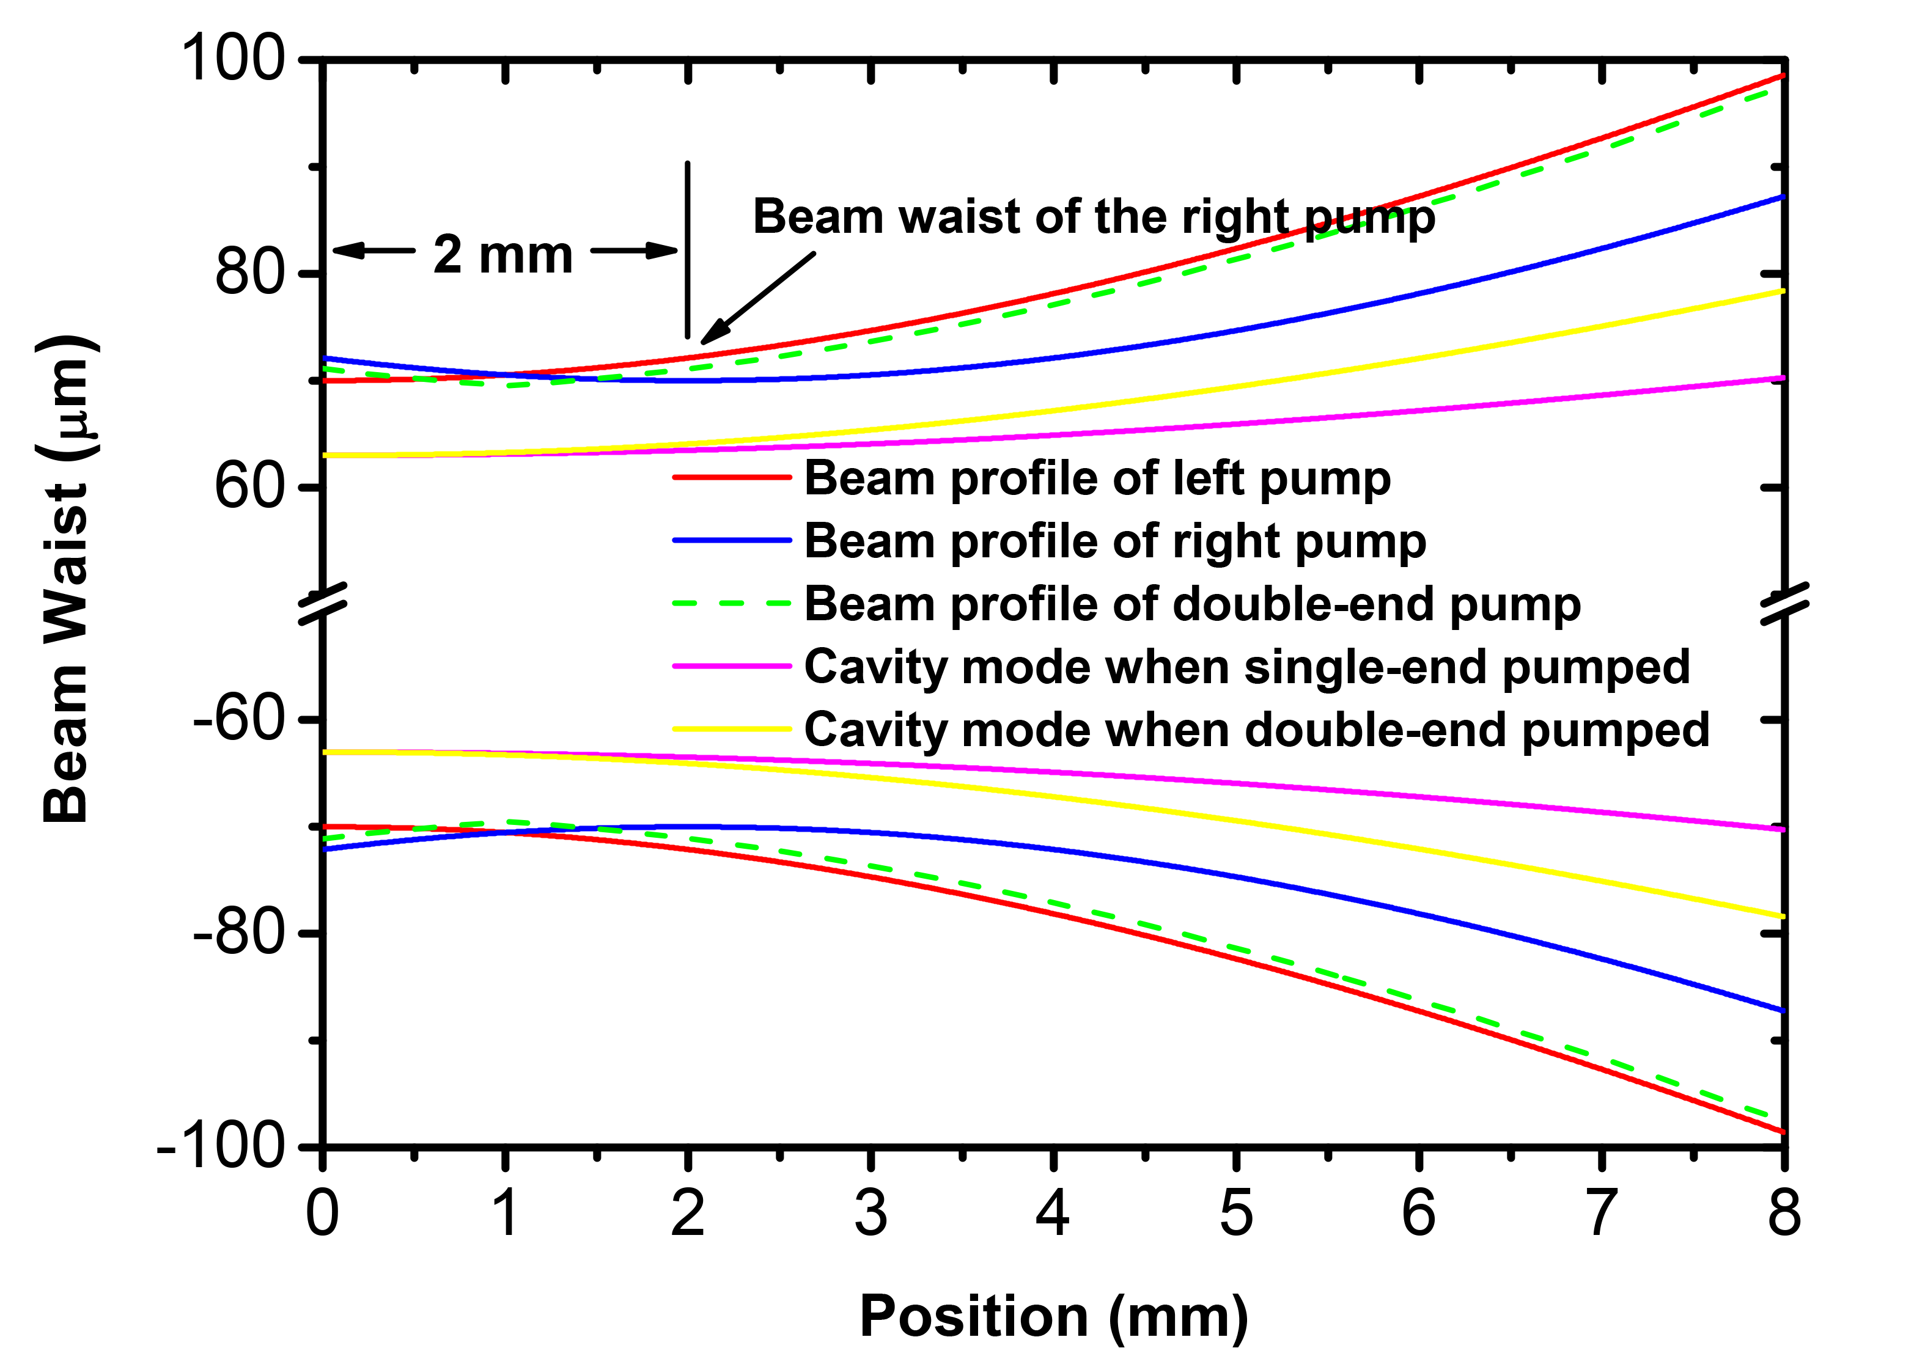

Fig 1. Beam profile of the pump and intra-cavity mode under single-end pumped and double-end pumped schematic in the gain media.

As depicted in Figure 1, generally speaking, by employing diode-double-end pumped structure, the beam waist and divergence angle of the pump profile increased, resulting in a larger part of the gain media involved in the lasing process, which contribute to a more vibrant laser performance.

To be specific, by utilizing Spiricon M2-200, for the pump source being focused by the 50 mm focusing lens, the beam waist and M2 were measured to be ~70 μm and 4.3, respectively. The displacement of the focusing points of the two pumps were measured to be ~2 mm. The beam profiles of the left and right pump in the laser crystal, which has a length of 8 mm, are depicted by the red and blue lines. The total pump profile under double-end pumped schematic is shown by the green dashed line. For intra-cavity mode, when the system was single-end pumped, the beam waist and M2 were measured to be ~63 μm and 1.2, while under double-end pumped schematic, the beam waist remained almost unchanged and M2 raised up to 1.8. The beam profiles of the cavity mode under single-end pumped and double-end pumped schematic are plotted by the magenta and yellow lines.

By introducing volume integral method, the overlapping efficiencies, which is described by the division of the volumes of cavity mode and pump accordingly, were calculated to be 66% and 72% under single-end pumped and double-end pumped schematic, respectively. That is to say, by making use of double-end pumped schematic, the overlapping efficiency increased, leading to an increased slop efficiency and better laser performance.

1. Different order in description of setup:
2. The information on the Pr:YLF-crystal should be positioned directly behind the information on the pump lasers because they are strongly connected.

**Response**:

We thank the reviewer for his/her advice. The paragraph of description for the laser gain media is removed to the place right behind the information on the pump lasers.

1. Missing information on Mirrors:
   * 1. The pump mirrors IM1&2 are plane, aren’t they?

**Response**:

We thank the reviewer for his/her advice and replaced the sentence “IM1 and IM2 have high transmission (>95%) at ~444 nm …” as “IM1 and IM2 are plane mirrors and have high transmission (>95%) at ~444 nm ...”.

* + 1. What about the transmission @698 and 720 nm (stronger emission compared to 523 nm) of IM1&2 mirror in the green laser?

**Response**:

For the green laser, input mirrors (IM1 and IM2) have high transmissions up to 80% and 87% @698 and 720 nm, respectively.

* + 1. What are the angles of incidence on the curved mirrors and is astigmatism a problem?

**Response**:

Astigmatism is indeed a problem, to mitigate it, the angles of incidence on the curved mirrors should be minimized as much as possible. In our experiment, the angles are around 10 degrees.

1. Missing information on spatial properties of the laser
   * + 1. What does the beam profile look like (maybe at different points of a caustic (e.g. near- and far-field)?

**Response**:

Intuitively, the output beam profile exhibits an elliptical shape having major axis in the x direction. Rigorously, the M2 factors of output laser beams were measured to be around 1.9 and 1.2 in the x and y direction, respectively, meaning a more divergence angle in x direction.

* + - 1. What is the beam quality in both direction at different points of the power curve? I would bet that it changes when the second pump laser is added.

**Response**:

The M2 factors of output laser beams vary from 1.6 to 1.9 and 1.0 to 1.2 in the x and y direction, respectively, as the pump power increases from laser threshold to the maximum. Generally speaking, the output beam qualities decrease slightly along with the increasing of pump power, during that process, no obvious degradation was found when the second pump laser was added.

1. Spectrum of the laser:
   * + 1. When determining the spectral width with FWHM, there should be a fitting curve on the measured data. By using the very small but high peak (could be an artifact) as the maximum of the spectrum the determined width is to narrow.

**Response**:

The Spectrum of the laser was not fitted because we are not sure which type of line shape, for example, Gaussian, Lorenz or something else, should be used. In fact, the underlying mechanism for self-mode locking is still non-deterministic and we are now devoting ourselves to exploring it.

1. Mode locking operation:
2. At which pumping power does the mode locking operation occur? Does it change with increasing pumping power?

**Response**:

The threshold for mode locking operation was kind of tricky. Before mode locking operations were established, the threshold reached around 800 mW and 1 W for red and green emission with respect to absorbed pump power, which is a bit higher than the lasing threshold. However, after mode locking operations were established, the mode locking threshold could be as low as the lasing threshold.

1. The pulse duration would be a very interesting parameter of your laser. Can you measure it?

**Response**:

Since we do not have the equipment such as high speed oscilloscope and photo detector or autocorrelator in the visible region, it was a pity that we couldn’t measure the exact profile of one single pulse.

1. Why do you think, that the mode locking occurs due to the kerr effect? In your Ref. [8] it is shown/calculated that it is very unlikely that Pr:YLF as a medium with a low nonlinear refractive index is suitable to archive mode locking. Please give some reasons and discuss your assumption.

**Response**:

The essential mechanism underlying mode locking operations is always intensity modulation, which could not be caused by anything but Kerr effect. Even though Pr:YLF crystal has a low nonlinear refractive index, Kerr effect could be stimulated as long as the intensity is strong enough.

1. Minor misspellings:
2. “HR1~HR3” instead of “HR1-HR3”
3. “slop” instead of “slope”
4. “Fig. 3 (c)” instead of “Fig. 5 (c)”

**Response**:

1. We thank the reviewer for his/her advice. “HR1~HR3” was replaced by “HR1-HR3”.
2. We thank the reviewer for his/her so careful checking of our submitted manuscript. “slop” was replaced by “slope”.
3. We thank the reviewer for his/her so careful checking of our submitted manuscript. “Fig. 3 (c)” was replaced by “Fig. 5 (c)”
4. References:
   * + 1. The average power, described in [1], is several 100 W and therefore out of reach for the laser you suggest. Please find a more relevant application for example in bio analysis.
       2. The effect that is described in [10] does not work in solid state gain media without GVD compensation, as it is stated in the paper itself. Therefore I don’t think that this reference is relevant for your work.
       3. You do not use your Ref. [9] somewhere in the text. Why is the SLM operation of Pr:YLF laser relevant in your work?

**Response**:

1. We thank the reviewer for his/her advice. The sentence “leading to a useful application of metal processing” was revised as “leading to a useful application of bioanalysis”, and Ref. [1] was replaced as the below one

[1] B. S. Edwards, J. S. Zhu, J. Chen, M. B. Carter, D. M. Thal, J. J.G. Tesmer, S. W. Graves, and L. A. Sklar, “Cluster Cytometry for High-Capacity Bioanalysis”, Cytometry Part A, 81A: 419-429 (2012).

1. Ref. [10] suggested a novel self-mode-locking (SML) mechanism in narrow-band lasers for both Gaussian and Lorentzian line shape, which correspond to liquid or solid lasers and gas lasers, respectively. Furthermore, rough criterion for SML was given, with no need of GVD at all.
2. We thank the reviewer for his/her so careful checking of our submitted manuscript. Ref. [9] in our original manuscript was deleted and Ref. [10] was removed to Ref. [9].

**Reviewer #2**

This is a very good paper that is also well-written. It is surprising however that the authors do not provide any measurement of the FWHM pulsewidth obtained, but rather just show in Figure 4 the train of pulses measured with a photodiode incapable of resolving individual pulses. For a quoted FWHM bandwidth of 0.39 nm for the 639 nm laser, one would expect to obtain transform-limited pulses in the low ps regime, and such pulses can easily be resolved using an autocorrelator. I suggest that either the authors provide autocorrelation measurements if available to them, or that at least they provide an estimate of the obtained pulsewidths calculated assuming transform-limited pulses. The inclusion of pulsewidths or estimates would make this paper much more comprehensive, filling a void that most readers will expect to find.

**Response**:

We thank the reviewer for his/her advice. As stated above, it was a pity that we did not have the precise enough equipment to register the profile of a single pulse. The reason why we did not estimate the obtained pulse widths calculated assuming transform-limited pulses is that the relatively low resolution (0.08 nm) of the used spectrometer would result in a relatively high time-bandwidth production [6], which should be meaningless.